**Set Functions:**

**Add():**

The Python set add() method adds a given element to a set if the element is not present in the set in python.

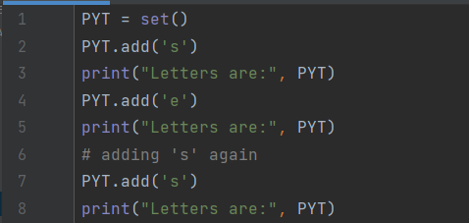

**Output:**

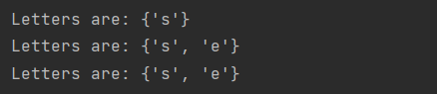

Adding element that is present in the set

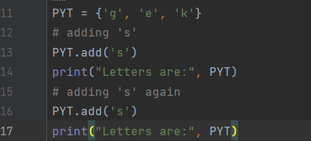

**Output:**



Adding iterable to a set

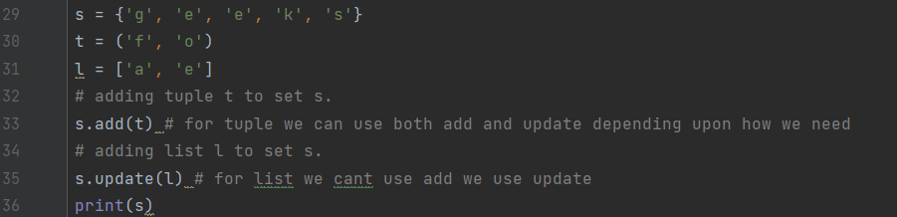

**Output:**



**Clear():**

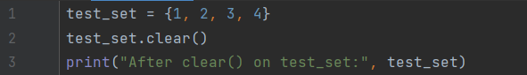

**Output:**



Clear on strings

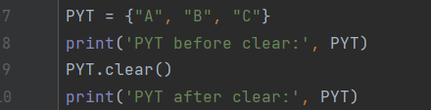

**Output:**



**Copy():**

The copy() method returns a shallow copy of the set in python.

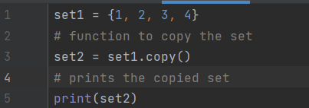

**Output:**



**Shallow copy**

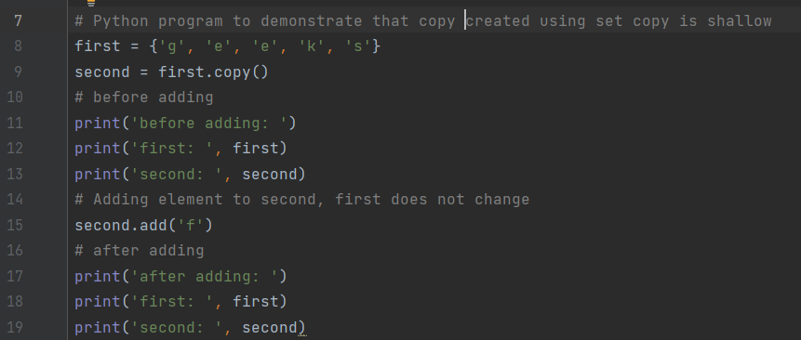

**Output:**

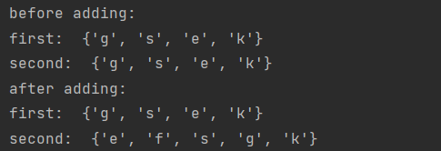

**Discard():**

Python discard() is a built-in method to remove elements from the set. The discard() method takes exactly one argument. This method does not return any value.

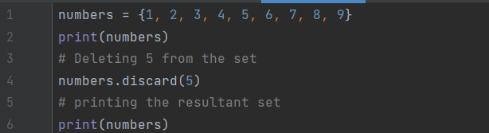

**Output:**

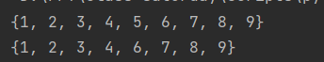

Discard() an item from a set that is not present in the Python set

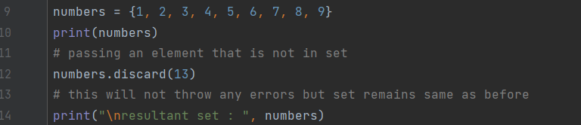

**Output:**

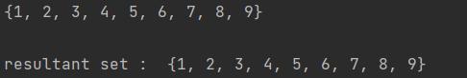

Discard() a String item from a set that is present in the Python Set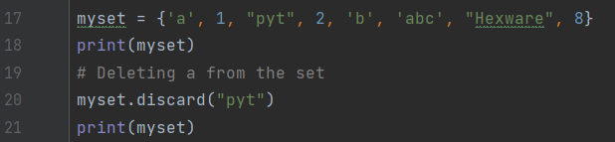

**Output:**



Discard() String item from a set that is not present in the Python Set

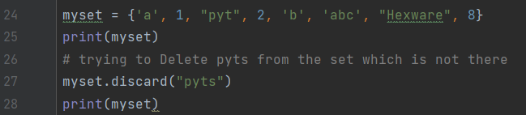

**Output:**

